**Program Documentation and Briefing**

RoadMap And Car Simulator

Submitted by: Gil Emmanuel Bancud

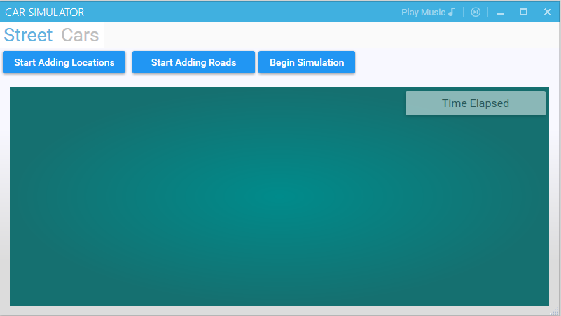

**Project Overview:**

The project aims to build a system using key data structures, Graphs and Stacks, in order to visualize real-timed shortest path traversals using cars and locations. The user may build his appropriate roadmap and create cars with origins and destinations. Simulation shows the cars progress and trajectory in the roadmap.

**Key Features:**

* Add Locations (Vertices)
* Add Roads (Edges)
* Car System (Shortest Path Algorithm)
* Realtime Simulator and Visualizer

**Additional Features:**

* Point drag and drop
* Background music
* Snackbar notifications
* Flyout car adder
* 3 different Car models

**Usage**:

1. Create locations (Add Vertices)
2. Create roads in between locations (Add Edges)
3. Create cars
4. Simulate

Key Obstacles and Constraints:

* MVVM implementation with canvas control for element bookkeeping and rendering.
* Edgeless graph implementation lacks thorough documentation.
* Non-performant canvas control on time-based code behind events
* Rendering pipeline optimization
* Car system debugging

Suggested Additions (Original Scope):

* Coupled Car Interaction System
* Stoplight Functionality
* Flexible Shortest path algorithm